Benchmark Exercise Report
Learning How to Learn-Exploring Ulrich Boser’s Book “Learn Better: Mastering the Skills for Success in Life, Business, and School, or, How to Become an Expert in Just About Anything”

Mathematics, Physics, and engineering Department, Wake Technical Community COllege, Raleigh, NC

April 21, 2018
Ted Maynard
Associate Professor of Mathematics & Physics

Benchmark Exercise Report
Learning How to Learn-Exploring Ulrich Boser’s Book “Learn Better: Mastering the Skills for Success in Life, Business, and School, or, How to Become an Expert in Just About Anything”
PROBLEM IDENTIFICATION
The approach to learning has changed very little over the last several centuries. Learning has been considered to be a simple matter of memorizing facts. It has been taken for granted that knowing the right facts would make one successful in the endeavor of his or her choice, and that these facts would be just what is needed for the situation at hand. Only recently has the field of “metacognition” or “thinking about thinking” or “learning how to learn” been considered in any systematic way. It is important to consider not just what to learn, but how to learn. Especially today when “facts and figures flow as freely as water in a stream,” we need to consider how the human mind works and then develop strategies that accommodate its limitations. Boser in his book presents six key steps that can improve the mind’s ability to consolidate facts into meaningful knowledge. According to this book, “learning is a mental form of doing.” In this benchmarking report we will examine just what he means by that statement.
Outstanding Leader Contacted
Ulrich Boser is a senior fellow at the Center for American Progress in Washington D.C. He is also the founder of The Learning Agency. This benchmarking exercise is based on his book Learn Better: Mastering the Skills for Success in Life, Business, and School, or, How to Become an Expert in Just About Anything. Amazon nominated this book as one of the “Best Books for the Year” for 2017. His email is ulrich@ulrichboser.com
Brief Summary of Information Obtained
The book cited Bill Gate’s 32-million dollar study “Measures of Effective Teaching.” Out of that study came two main drivers in teaching for student outcomes: 1) “Academic Press” or the teacher making sure that the student does the hard work of making sense of something. “Meaning – making is rare.” But it takes mental work to find meaning. The mind can either function automatically and quickly, or deliberately and slower. The latter requires mental effort. Learning is iterative and reflective. Reflection involves hard work. “The more someone is actively engaged, the more they learn.” What about the iterative part? It is not passive iteration, it is iterating with active engagement. The book cites a study where a group that practiced recalling a passage learned a lot more than those who simply re-read the passage. The mind is much like a muscle that will become flaccid from under use. You “learn a lot more if you ask yourself questions after reading this text than simply re-reading it.” Traditional lecture is not the same thing as “active engagement.” “Students in traditional lecture-based courses are 50 percent more likely to fail, according to one recent study.”
2) “Academic Support” or the instructor serving as a “cognitive coach” for the student. The instructor should not assume that a topic comes naturally to a student. “We don’t know what we don’t know.” “We need other people to help us make sense of a topic.” Newtonian physics or the intricacies of how the human body works were developed by brilliant minds over hundreds of years. It is not likely that the student will “discover” an understanding of such complex topics without guidance from an instructor with expertise on the topic at hand. The “value of educators” includes parsing out the “chunks” of what is to be learned. “Think of learning as figuring out parts of an organized and intelligible system.” The instructor is responsible for “target,” which is one of the six elements of a “systematic approach to developing expertise” that are elaborated in the book. One group of dart throwers is told to “hit the bullseye.” Another group was given the key steps, such as “keep your arm close to your body.” The latter group performed better. And they wanted to know more about throwing darts. This is the reflection or thinking about what you are doing mentioned earlier. It is not the automatic quick but easier mode of the mind, it is the slow deliberate mode. The dart throwers realized “value;” if a student sees value in something, he or she is more likely to try to “fill in the gaps” about it. Value comes from finding meaning, and “meaning scaffolds meaning.” This is more likely to happen if the instructor, with more knowledge and experience than the student, targets what is important.
Some thought should be devoted to how the human mind works. Consider the mind as a “CPU” capable of internalizing facts delivered to it by a straw. The CPU cannot process but one thing at a time and at a rate provided by the straw. A higher flow rate will not be processed optimally. “We learn better in smaller doses.” “Short sentences are a writer’s best friend.” The optimal input rate will push the mind to just beyond its comfort level. “A study found that teachers who give three- to five- second pauses when explaining ideas have students who learn a lot more.” Students do not do well with a drinking – out – of – a – firehose delivery. Boser labels the brain’s short term memory as its “sketch pad,” and the “bottle neck of learning.” “If too much information lands in short term memory at one time, then our cognitive sketch pad becomes overwhelmed.” Analogies should be used. The straw and sketch pad are analogies. The mind can learn a new structure by comparing the differences and similarities of a known structure. Analogies are a form of mental scaffolding.
Does it matter how the facts are “chunked?” Suppose you are preparing a talk that has four sections. Is it better to practice the entire talk for a fixed amount of time each day for four days? Or should you focus on one section each day for the same amount of time as the other approach? Most people think the latter would be more effective, but the book presented a study showing that the former method had better results. “Anything we can do to distribute our learning over time pays off, and people should space out the development of a skill.” In “mixed learning” one is more likely to see the “core idea,” to see the whole and how its parts fit together. Another aspect to “spreading out our learning” is that “we forget half of what we have learned within 24 hours.” Important ideas must be re-enforced periodically. How we learn is as important as what we learn.
Should learning be broad and shallow or focused and deep? The latter is far more effective. Learning is more effective when there is mental effort to penetrate deeply into a concept to find meaning and connections. A study was cited where the audience was given 24 words and without their knowing were partitioned into four different groups. This was accomplished by giving them four different sets of written instructions. Half were told to note which words had the letters “e” or “g.” The other half were to note which words were “pleasant” or not. Half of each half were told that they would be asked to recall as many words as possible, and the other half was not. Regardless of whether subjects were told that they would need to recall the words, those who judged whether the word was pleasant recalled markedly more words. Meaning matters. Mental doing matters. Whether or not the word had certain letters was a lower level of thinking than making a judgement on whether a word had a pleasant connotation or not.
Learning is about making connections. The more connections we make between ideas, the more meaning those ideas have. It is important to push students to put into their own words what something means, and that involves making connections. Think of the game of Yathzee for an analogy: More points are awarded for creating words both perpendicularly and horizontally. Our minds place little value on facts that are not connected to other facts. Along this line, the book states that “the more that you know about something, the more that you can learn about that something.” That is to say, in learning there is a “The rich get richer” aspect. The more we know about something, the more that we want to know. We want to “fill in the gaps” to find “meaning.” We are by nature curious. Meaning is “self-perpetuating.” “The single best predictor of future learning is past learning.” Facts do matter, but they are useless in isolation. Meaning is the beginning of learning, and facts are the beginning of meaning. But this cannot occur without mental doing. Most have heard the aphorism “Knowledge is power.” More precisely, “Knowledge combined with thought is power.” Power comes from making connections to find meaning, and making connections requires mental doing or thought.
The above hopefully provides some insight into what this important book is all about. The author has provided a follow on article which summarizes the key points of the book titled The Ten Commandments of Learning. Here is a link to that article, at http://ulrichboser.com/ten-commandments-learning/

Action Plan
Experiment with strategies from the book. These will include:
- Routine use of “What if?” questioning. Boser in the book relates the steps of the scientific method as:
  - Look at the evidence,
  - Develop a theory,
  - Test the theory,
  - Come to a conclusion.
Or more succinctly “Theorize, test, repeat.” The scientific method is iterative, as the researcher is expected to refine the theory and then re-test based on the results of previous iterations. Reducing the scientific method even further, it is “not much different than a ‘what if’ question.” “People can gain a lot by discussing the implications of hypotheticals.” I want to use what if questioning to get students thinking more in depth about things. Use of such questioning is a more student – centered approach rather than a lecture delivery approach, which has been shown to be too passive to be effective.
- Use of concept maps. A “cousin of the Venn diagram,” these provide a graphical depiction of relationships for something, fostering us to be able to understand connections, and showing “deeper associations.” Two examples are shown below:
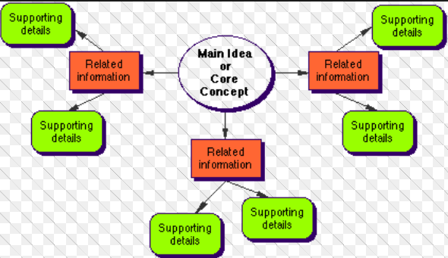

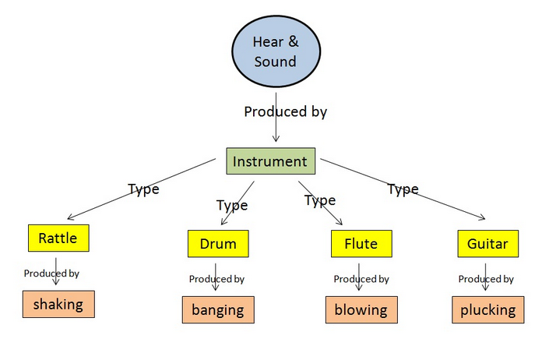
Results of Action Plan
- To be determined.
Conclusion
- This is an excellent book for anyone who is interested in “metacognition” or “thinking about thinking.” Since human beings are unique in ability to act based on reason rather than instinct, metacognition is of interest to any sentient person. This book is highly recommended for any educator.

